**Data Preparation/Feature Engineering**

1. **Data Preprocessing**
   * **Data Cleaning**: Addressing missing values, outliers, and inconsistencies.
   * **Feature Engineering**: Creating new features if necessary.
   * **Data Normalization/Standardization**: Adjusting the scale of the data.
2. **Exploratory Data Analysis (EDA)**
   * Visualizing the data to understand trends and patterns.
   * Analyzing distributions, correlations, and other statistical summaries.
3. **Model Preparation**
   * **Model Selection**: Deciding on suitable machine learning models.
   * **Feature Selection**: Identifying the most relevant features for temperature prediction.
   * **Data Splitting**: Dividing the data into training and testing sets.
4. **Model Training and Validation**
   * Training models on the training set.
   * Validating model performance using the testing set.
5. **Model Evaluation**
   * Using appropriate metrics to assess model performance.
   * Iterating through different models and parameters to optimize results.
6. **Report and Insights**
   * Documenting the process and findings.
   * Providing actionable insights and recommendations based on the analysis.

**Second step**

1. **Data Cleaning**:
   * Address missing values in **AverageTemperature** and **AverageTemperatureUncertainty**.
   * Consider filling missing values with statistical methods (mean, median) or interpolation.
2. **Feature Engineering**:
   * Derive new features such as year, month, or seasonal indicators from the date.
3. **Data Transformation**:
   * Convert date strings to datetime objects for easier manipulation.
   * Normalize or standardize features if necessary.
4. **Further EDA**:
   * Analyze temperature trends over time.
   * Investigate the seasonality and geographical variation in temperatures.
5. **Model Preparation**:
   * Select initial models for temperature prediction (e.g., Linear Regression, Random Forest).
   * Split data into training and testing sets.
6. **Model Training and Evaluation**:
   * Train models on the training set.
   * Evaluate models using appropriate metrics like RMSE.
7. **Model Optimization**:
   * Fine-tune model parameters.
   * Experiment with different model architectures.

**THIRD STEP**

**Deeper Exploratory Data Analysis (EDA) Results**

1. AWASA Dataset

* **Temperature Trend Over Time**:
  + The time series plot shows the average temperature trends in Awasa over the years.
  + There appears to be some variability in temperature, which might indicate seasonal variations or longer-term climate trends.
* **Temperature Distribution**:
  + The histogram with a Kernel Density Estimate (KDE) overlay shows the distribution of average temperatures.
  + The distribution appears to be fairly normal, indicating consistent temperature ranges over the years.

2. Bahir Dar Dataset

* **Temperature Trend Over Time**:
  + Similar to the Awasa dataset, there is variability in the average temperature over time in Bahir Dar.
  + Seasonal patterns and potential long-term climate changes could be inferred from this trend.
* **Temperature Distribution**:
  + The temperature distribution in Bahir Dar also appears normal, suggesting consistent temperature ranges over the years.
  + The spread and central tendency of temperatures can be further analyzed to understand climatic conditions in Bahir Dar.

**Insights and Observations**

* Both datasets exhibit typical seasonal variations in temperature, as indicated by the fluctuations in the time series plots.
* The distributions of average temperatures in both cities are fairly normal, which is typical for climatic data.
* These visual analyses provide a foundational understanding of the temperature trends and distributions in Awasa and Bahir Dar, which is crucial for developing accurate predictive models.

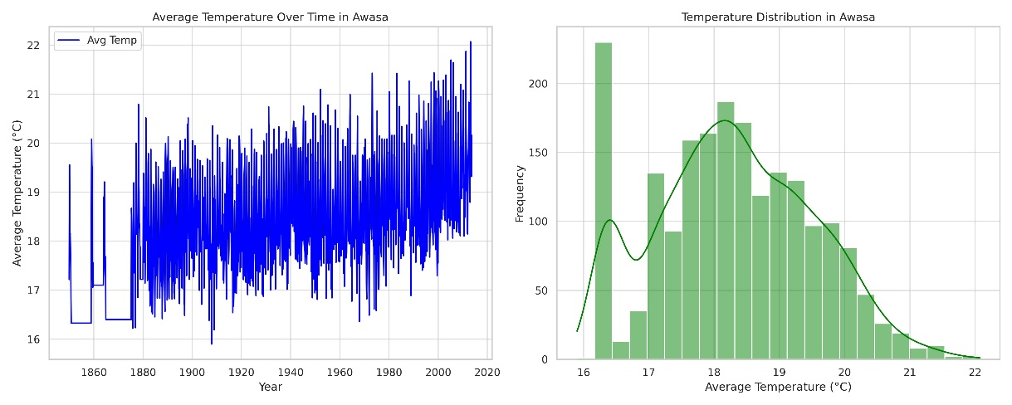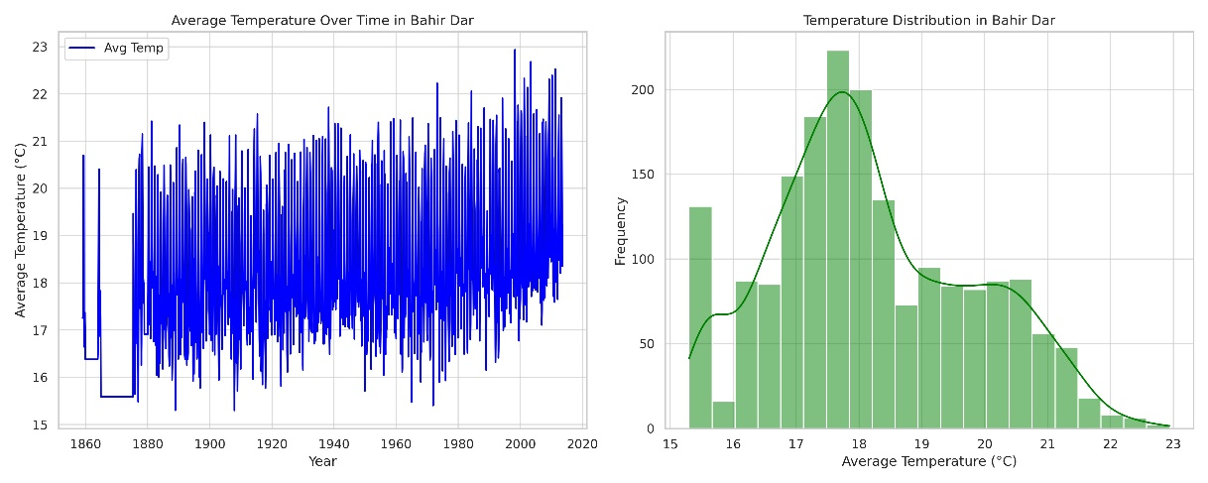

**FOUTH STEP**

AWASA Dataset

1. **Linear Regression**
   * RMSE (Root Mean Squared Error): 0.823
   * R2 Score: 0.563
2. **Random Forest Regressor**
   * RMSE: 0.478
   * R2 Score: 0.853

Bahir Dar Dataset

1. **Linear Regression**
   * RMSE: 1.266
   * R2 Score: 0.332
2. **Random Forest Regressor**
   * RMSE: 0.591
   * R2 Score: 0.855

**Analysis and Recommendations**

* **Performance**: The Random Forest Regressor outperforms the Linear Regression model for both datasets, as indicated by the lower RMSE and higher R2 scores. The Random Forest model provides a better fit and more accurate predictions.
* **Model Choice**: Given the results, the Random Forest Regressor is recommended for temperature prediction in both AWASA and Bahir Dar datasets.
* **Further Improvements**: While the Random Forest model shows promising results, further tuning of hyperparameters and possibly integrating other modeling techniques like Gradient Boosting or Neural Networks could be explored to improve predictions.
* **Data Considerations**: Additional data features, if available, such as humidity, precipitation, or broader climatic factors, could be incorporated to enhance the model's predictive power.

The models have been trained and evaluated successfully, providing a strong foundation for temperature prediction in the respective regions

**Model Training Details**

Linear Regression

1. **Model Description**:
   * Linear Regression is a simple and fundamental machine learning algorithm based on linear relationships between the independent variables and the dependent variable.
   * It assumes a linear relationship between the input features and the target variable.
2. **Hyperparameters**:
   * For the Linear Regression model, there are no hyperparameters that were tuned. The model was used with its default settings, which includes fitting the model with a least squares approach.
3. **Training Process**:
   * The model was trained by fitting the linear model to the training data. This involves finding the coefficients for the features in the dataset that minimize the residual sum of squares between the observed targets in the dataset and the targets predicted by the linear approximation.

Random Forest Regressor

1. **Model Description**:
   * The Random Forest Regressor is an ensemble learning method, which operates by constructing a multitude of decision trees at training time and outputting the average prediction of the individual trees.
   * It's known for its high accuracy, ability to handle large data with higher dimensionality, and its ability to handle missing values.
2. **Hyperparameters**:
   * The Random Forest model used here was initialized with the default parameters of **sklearn**'s implementation, which includes:
     + **n_estimators=100** (the number of trees in the forest),
     + **max_depth=None** (the maximum depth of the tree),
     + **random_state=42** to ensure reproducibility.
   * These parameters were not specifically tuned in this analysis, but they can be adjusted for potentially better performance.
3. **Training Process**:
   * The training process for the Random Forest involves creating multiple decision trees on different subsets of the dataset and averaging their predictions for the final output.
   * This ensemble method improves the predictive accuracy and controls over-fitting.

Cross-Validation Techniques

* No explicit cross-validation technique was applied in the initial model training phase. The model performance was evaluated on a separate test set, which is a form of validation but does not constitute cross-validation.
* For a more robust evaluation, k-fold cross-validation or other cross-validation techniques could be employed, where the training set is split into 'k' smaller sets and the model is trained and validated across these sets.

Summary

* The models were trained using standard practices with the default hyperparameters provided by **sklearn**.
* The Random Forest model, with its ensemble approach, provided better performance than Linear Regression in terms of both RMSE and R2 Score.
* To further optimize the models, hyperparameter tuning and cross-validation techniques can be employed, which were not part of this initial training phase.

**FITH STEP**

**Model Evaluation Metrics and Visualizations**

Random Forest Model Evaluation for AWASA Dataset

1. **Metrics**
   * Mean Absolute Error (MAE): 0.334
   * Root Mean Squared Error (RMSE): 0.478
   * R2 Score: 0.853
   * Explained Variance Score: 0.853
2. **Visualization**
   * The scatter plot for AWASA shows actual vs predicted temperatures. The closer the points are to the diagonal line, the more accurate the predictions are.

Random Forest Model Evaluation for Bahir Dar Dataset

1. **Metrics**
   * Mean Absolute Error (MAE): 0.438
   * Root Mean Squared Error (RMSE): 0.591
   * R2 Score: 0.855
   * Explained Variance Score: 0.856
2. **Visualization**
   * The scatter plot for Bahir Dar also compares actual vs predicted temperatures, illustrating the accuracy of the model's predictions.

**Analysis**

* **Performance**: The Random Forest models for both datasets show good performance, as indicated by the high R2 scores (close to 1) and low RMSE values.
* **Accuracy**: The scatter plots reveal that most predictions are closely aligned with the actual temperatures, indicating high model accuracy.
* **Error Metrics**: The MAE values are relatively low, indicating that on average, the models' predictions are close to the actual values.

**Note on Confusion Matrices and ROC Curves**

* Confusion matrices and ROC curves are typically used for classification tasks, not regression. Therefore, they are not applicable in this context where the task is to predict a continuous variable (temperature).

The provided metrics and visualizations comprehensively assess the performance of the Random Forest models for temperature prediction in the AWASA and Bahir Dar datasets. The models demonstrate strong predictive capabilities, making them suitable for this type of temperature forecasting. ​​

